**Project 1: White Paper Draft**

Mithil Patel

Bellevue University

DSC680-T302 Applied Data Science

Prof. Catherine Williams

April 9th, 2023

**Business Problem**

Due to the modern lifestyle, humans are sleeping less compared to people in the past. As a result, many find themself dozing off during an activity such as homework or driving a car. Drowsiness is a dangerous behavior that can lead to deadly consequences for the parties involved. According to the National Highway Traffic Safety Administration, an estimated 72,000 crashes, 50,000 injuries, and 800 fatalities result from drowsy driving each year in the United States alone. The danger of sleeping behind the wheel cannot be understated, and it is crucial to take preventive measures to prevent tragic accidents. Therefore, developing a cost-effective drowsiness alert system can improve car safety by sending push notifications to a driver’s desired platforms (email, phones, etc.) as the driver falls asleep behind the wheel.

The safety feature can assist a driver in avoiding legal consequences (license suspension or imprisonment) for operating a motor vehicle drowsy. Additionally, the alert system can lower insurance premiums for many drivers as insurance companies will consider them safe drivers. Above all, due to the low cost of research and development of the alert system, the following technology can be implemented in low-priced cars, providing an important safety feature for drivers in low-income groups.

**Background/History**

Due to the increasing number of car accidents caused by drowsiness in the early 2000s, the dire need for developing drowsiness alert technology has become more pressing to prevent further road tragedies. Driving while feeling drowsy can be as dangerous as drunk driving as it can impair a driver’s judgment, decision-making ability, and reaction time. Therefore, automobile companies began to explore ideas to enhance driver safety, one of which was a drowsiness alert system. In 2007, Volvo Cars introduced the world’s first drowsiness detection system called Driver Alert Control (DAC), which monitored a driver’s behavior, such as a decrease in steering movement or drifting out of lane, to issue a warning. Later, Mercedes-Benz launched its version of the detection system called Attention Assist, which used sensors to monitor fatigue levels and issue a warning. Ever since then, many automakers have launched their versions of the Driver Drowsiness Detection System (DDDS) to improve public safety.

In the last few years, the drowsiness alert system has drastically advanced as they incorporate sophisticated sensors and artificial intelligence to detect accurately detect signs of drowsiness. However, the accessibility of the alert system in cars is imperative to prevent drowsiness-related accidents from occurring. Since detection systems exist primarily in high-end cars, a basic version of the system is required in more affordable vehicles as they account for the majority of the cars on the road. Hence, the purpose of this project. Developing a cost-effective drowsiness alert system is necessary to address the risk surrounding drowsiness and help ensure drivers arrive safely at their destination.

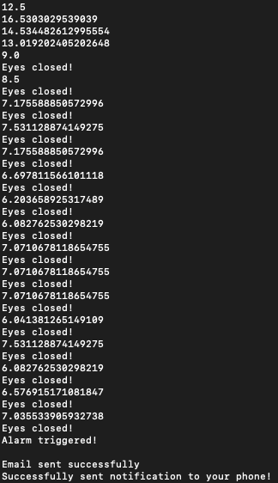

**Fig. 1**: The vertical line thickness values used to identify fatigue level.

**Data Explanation (Data Prep/Data Dictionary/etc)**

Since the driver sleeping alert system does not involve creating a regression or classification model, the project will not use a conventional dataset presented in a table format. The alert system will instead use a camera to collect real-time data, especially eye movement data, from the driver to detect their fatigue state by monitoring eye closure duration and changes in the head movement, such as tilting to the side. The raw data collected from the user’s eye behavior will be used for detection; therefore, the data does not require manipulation/transformation. Figure 1, shown above, displays the thickness value of the vertical line mapped onto the driver’s eyes (Figures 4 show the lines mapped on a face). Processing real-time data will be imperative for the alert system to determine the sending of push notifications to the user to prevent car-crash fatalities.

**Methods**

Like many revolutionary inventions, a concrete methodology is essential to create an alert system that detects whether a driver is falling asleep behind the wheel. OpenCV, an open-source computer vision library in Python, will be used for video processing and object recognition. Along with OpenCV, dlib uses a pre-trained model for detecting eye landmarks to detect eyes in video streams accurately. Once the camera is activated using openCV, a shape_predictor_68_face_landmarks.dat file, a pre-trained prediction algorithm in the dlib library, was used to detect landmarks on a person’s face (shown in Fig 2). Using the landmarks from Figure 2, a horizontal and vertical line can be generated to capture eye movements. The eye movements can be observed if there is a change in the thickness of each line. As mentioned earlier, the values in Figure 1 represent the thickness of the vertical line. Since eye closing is a vertical movement, the change in the vertical line will be a good indicator for eye closure in our system. In our case, the average vertical thickness length below ten is considered an acceptable value for an eye closure.

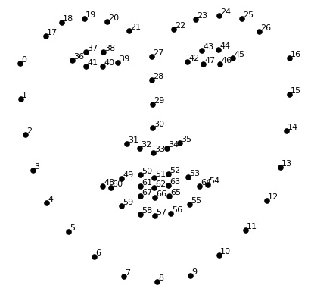

**Fig. 2**: A shape_predictor_68_face_landmarks pre-trained model shows the 68 (x-y) landmarks to detect facial features.

Once eyes are detected, the system will lock coordinates on the person's eyes to monitor for eye closure duration. Suppose the system detects the driver's eyes closed for over three seconds; the alerts will be activated, sending notifications to the user's phone and email. Smtplib (a built-in Python library) package can be utilized to send email notifications using the Simple Mail Transfer Protocol (SMTP). An API call was made to Pushover with the appropriate API token and user key to send notifications to a user's phone. Pushover is a cloud-based service that allows users to send push notifications to their mobile phones.

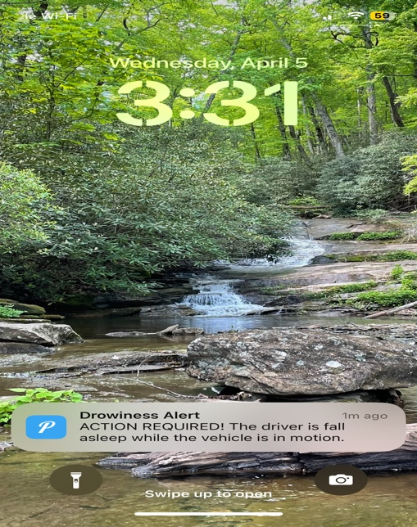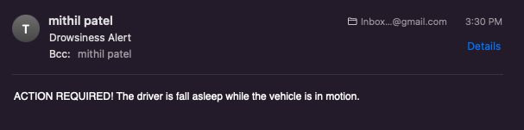

**Fig. 3**: Notification alerts sent to phone (right) and email (left).

**Analysis**

The driver sleeping alert system can primarily be validated through rigorous experimentation. The system was tested in real-world scenarios to determine its accuracy and reliability. For example, since sunglasses are standard accessories drivers wear to increase visibility, the drowsiness alert system was tested to detect fatigue, as shown in Figure 4. Unfortunately, the system could not pass the test since it could not detect eye landmarks properly with sunglasses covering the eyes. However, the system successfully detected eye closure through clear-lens glasses. Additionally, the alert system was tested when the test subject (myself) was at various distances away from the camera to assess the performance. Out of 9 trials, the system was able to detect eye closure all nine times when placed one arm's length away (the standard distance between the steering wheel and the driver) from the test subject. However, the system performance level began to drop as the distance between the camera and the subject increased. This is expected considering the camera's field of view decreases, thus, resulting in a lower resolution image as the camera is unable to capture enough detail to detect eye movement efficiently. There are many other scenarios the system will be tested on, such as different eye sizes, brightness levels, etc., to effectively measure the drowsiness alert system's validity, reliability, and accuracy.

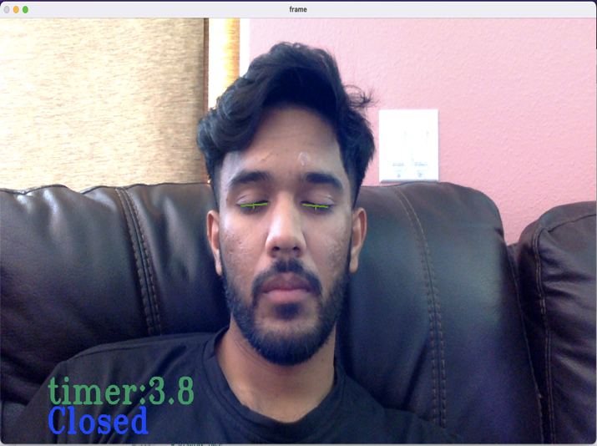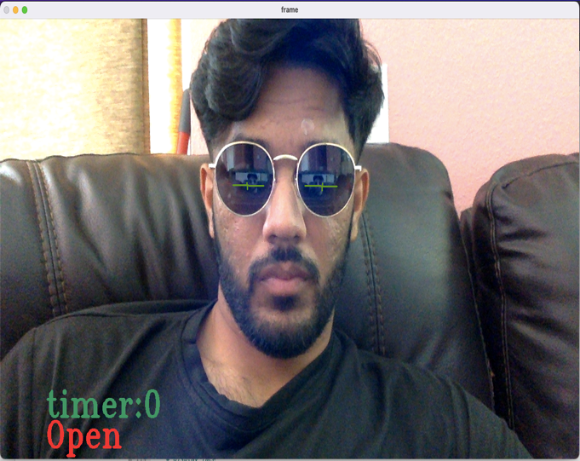Fig. 4: Conducting an experiment to evaluate the drowsiness alert system’s performance when the driver is wearing sunglasses.

**Conclusion**

In a nutshell, a high number of car crash involving drowsy drivers each year in the United States highlights the urgent need to improve automobile safety. Implementing a standard drowsiness alert system, which can track and analyze the driver's eye movements and provide warnings, can significantly reduce the likelihood of such tragic accidents occurring. The developed alert system will utilize Python open-source packages such as OpenCV and dlib for video processing and eye detection. By using basic mathematical concepts, the program can effectively detect eye closure and trigger a notification to the user's phone and email via a combination of built-in Python libraries and third-party notification services. The initial testing of the alert system showed promising results, as it successfully detected eye movements with high accuracy when the test subject was at arm's length from the camera. The system also proved effective in detecting eye movement when the test subject was wearing clear-lens glasses, although it performed poorly when conventional sunglasses were worn. Although the current version of the alert system relies solely on eye movements to detect drowsiness, its performance may be limited under certain circumstances. Further research and testing are necessary to fully evaluate the capabilities of the developed drowsiness alert system.

**Assumptions**

There are a few assumptions that were made during the developmental stage. To determine eye closure, the acceptable vertical thickness value was assumed to be ten. Additionally, three seconds was sufficient for a driver to be considered drowsy. Suppose the duration is set a bit longer. In that case, it may increase the chances of a tragic accident, while setting the threshold too short may neglect natural eye movement such as blinking.

**Limitations**

A drowsiness alert system developed to trigger warnings solely based on eye movement may encounter several limitations. For instance, the system does not apply to all circumstances, such as a driver wearing sunglasses or someone with eye conditions that affect their eye movements. The system may perform poorly under various lighting conditions (i.e., dark). Depending on the video camera resolution, the alert system will require to be calibrated for each user, which can be proven to be time-consuming and inefficient.

**Challenges**

During the development of the alert system, I encountered several issues. The most significant challenge was finding suitable open-source libraries and packages to extract facial features and detect eye movement accurately. Additionally, it was difficult to determine the most effective approach for sending push notifications to the user's phone since I was working with a closed operating system like Apple's iOS. Finally, validating the alert system was challenging as there are no clear-cut indicators to detect drowsiness in a driver. Therefore, I made an assumption that if a driver's eyes remain closed for more than three seconds, they are likely feeling drowsy.

**Future Uses/Additional Applications**

There are various purposes of a drowsiness alert system besides detecting drowsy drivers. Since the system continuously tracks the user’s eye movements, it can be used in education to monitor student engagement levels. Teachers can gain insight into which learning material is captivating/exciting for students by tracking their eye movements. Similarly, the technology can also be utilized in market research or e-commerce. Researchers can gain valuable insights into consumer behavior by tracking which advertisements seem eye-catching and how they interact with products.

**Recommendations**

To improve the overall performance of the system, other metrics should be considered in addition to eye movement. For instance, the dlib library contains a pre-trained model for detecting facial landmarks, which could be used to incorporate head movement to detect drowsiness, if time permits. Including other metrics would be beneficial, especially when the driver is wearing sunglasses. However, detecting head movement, such as head tilt, could be challenging since there is no definitive head movement that humans make to indicate drowsiness. Another recommendation will be to conduct additional experiments, such as testing the system with various lighting conditions to validate the current version of the drowsiness alert system.

**Implementation Plan**

To set up a drowsiness alert system in a car, the Raspberry Pi camera module can be connected to the Raspberry Pi board to capture video recordings. The video data can then be stored on an external hard drive connected via USB, which can be used for video processing and analyzing images. With the ability to execute scripts on the Raspberry Pi, the alert system script can be connected to the camera module and run, creating a fully functional drowsiness alert system that is capable of sending alerts to the user's email and phone upon detecting drowsiness in drivers behind the wheels.

**Ethical Assessment**

The drowsiness system can promote better health by preventing accidents caused by drowsy driving. Moreover, fewer accidents would mean the insurance cost would be lower, and the driver may have avoided legal consequences. While the sleeping alerting system can be a helpful safety feature in cars, there are several ethical implications to consider ensuring the technology is used in a responsible manner. The most critical ethical concern to consider is privacy. Since the camera will monitor the driver's movements, the driver may perceive an invasion of privacy as if their movement is constantly being monitored. Additionally, if the vehicle's computer system becomes compromised, the alert system's camera can be used for surveillance by an attacker with ill intentions. Another ethical concern to bear in mind would be reliability. If the driver becomes too dependent on technology for safety alerts, it could lead the driver to avoid taking personal responsibility for staying alert behind the wheel when the system fails to alert in genuinely dangerous scenarios. The system can also discriminate against individuals with a medical condition affecting their eyes, resulting in the driver turning the system off due to multiple false positive instances. To address these ethical concerns, developers of a drowsiness detection system should prioritize accuracy and reliability in their design and testing and should be transparent about the limitations of the technology. Finally, they should also ensure that the system is only used with the driver's consent and that any data collected is protected and used only for its intended purpose.

**10 Questions an audience would ask you**

1. Can the system detect other factors that may contribute to drowsy driving, such as medication or alcohol consumption?
2. No, the system is unable to detect physiological signals such alcohol consumption since it was original intended detect drowsiness based driver’s eye closure.
3. What is the developmental cost of the system in a car, and will it increase the cost of the car?

A) Besides the manual labor to develop the script, we only need to invest in a Raspberry camera module, Raspberry Pi board, and a connector for each car; therefore, the total cost will be approximately $100, which is not a lot when compared to the average cost of a car.

1. Can the system be overridden, and if so, how does this affect its effectiveness?
2. No, the system cannot be overridden because it is intended to only send an alert to the user’s phone or email. However, it can be turned off if the user desires.
3. What is the accuracy rate of the system, and how is it tested?
4. The accuracy value is tricky to assess as it can vary depending on factors such as light condition, type of eyewear, or distance away from the camera. Once the system is calibrated for a particular driver, then it will be able to detect with over 95 percent accuracy (assuming it is daylight, and the driver is not wearing sunglasses). However, the system is more likely to perform poorly if there is a different driver.
5. Is the drowsiness alert system integrated with other safety features in the car, such as lane departure warning?
6. No, because the lane departure warning feature is provided through the car manufacturer, which I am not really part of. I am open to working with them to enhance car safety, but as of now, I am only involved with the drowsiness alert system.
7. Are there any plans to develop new or improved versions of the drowsiness alert system in the future?
8. Yes, we would ideally like to incorporate other metric like blink rate as mentioned before to improve the overall system accuracy and detection rate.
9. Will incorporating Raspberry Pi drive up the cost of the car? If so, by how much?
10. The system is an additional safety feature provided due to its relatively low cost; the price of the car will not be increasing.
11. When will the technology be ready for deployment?
12. Currently, the script is complete, but we still need to connect the Raspberry Pi camera module to the Raspberry Pi board and run the script there. To answer your question, the technology still needs to be prepared for deployment as it is still in the developmental stage.
13. Can the system adapt to different conditions, such as low or high brightness, that can affect eye movement?
14. Unfortunately, the system is unable to adapt to different conditions. That is one limitation, as it could not detect during nighttime or when the driver was wearing sunglasses. We will consider it for a newer version, including a night-vision camera instead of the standard camera.
15. Can the system be customized to fit the needs of different users?
16. Sadly, the system does require to be calibrated every time a different driver is behind the wheel. Further research is needed to investigate whether adjusting specific parameters can resolve the issue or if a camera with zooming capability is necessary.

**Reference**

* Choi, I. H., Jeong, C. H., & Kim, Y. G. (2016, May 7). Tracking a Driver’s Face against Extreme Head Poses and Inference of Drowsiness Using a Hidden Markov Model. MDPI. Retrieved April 7, 2023, from <https://pdfs.semanticscholar.org/bd1b/c046997fab49d24fa9d7f5f57e7ef8491d2a.pdf>
* “Driver Drowsiness Detection.” Wikipedia, Wikimedia Foundation, 29 Oct. 2022, <https://en.wikipedia.org/wiki/Driver_drowsiness_detection>
* Tefft, Brian C. “The Prevalence and Impact of Drowsy Driving.” AAA Foundation for Traffic Safety, 15 June 2018, <https://aaafoundation.org/prevalence-impact-drowsy-driving/>